- A perceptron model is trained on a dataset that is known to be linearly separable, yet the algorithm fails to converge even after many iterations. Analyze the possible causes of this issue, including improper learning rate selection, incorrect weight initialization, bias handling errors, or flawed implementation of the update rule. Propose debugging strategies to identify the root cause and suggest optimization techniques to ensure faster and stable convergence.
Code:
import numpy as np

class Perceptron:
def __init__(self, lr=0.1, n_iters=100):
self.lr = lr
self.n_iters = n_iters
self.w, self.b = None, 0

def fit(self, X, y):
n_samples, n_features = X.shape
self.w = np.random.randn(n_features) * 0.01
y_ = np.where(y <= 0, -1, 1)

for epoch in range(self.n_iters):
errors = 0
for xi, target in zip(X, y_):
if target * (np.dot(xi, self.w) + self.b) <= 0:
self.w += self.lr * target * xi
self.b += self.lr * target
errors += 1
print(f"Epoch {epoch+1}, Misclassified: {errors}")
if errors == 0:
print("Converged!")
break

def predict(self, X):
return np.sign(np.dot(X, self.w) + self.b)

# Example usage
X = np.array([[2,3],[4,5],[5,1],[1,1],[2,0],[0,2]])
y = np.array([1,1,1,0,0,0])

p = Perceptron(lr=0.1, n_iters=50)
p.fit(X, y)
print("Predictions:", p.predict(X))
output:
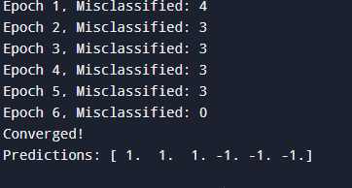

2. While training a multilayer perceptron using the backpropagation algorithm, the network exhibits slow convergence and gets stuck in local minima. Examine the potential reasons such as vanishing gradients, inappropriate activation functions, poor weight initialization, or suboptimal learning rates. Describe step-by-step debugging approaches to trace the issue and recommend optimization techniques like adaptive learning rates, normalization, or advanced optimizers to improve performance.
Code:
import numpy as np

# XOR Dataset
X = np.array([[0,0],
[0,1],
[1,0],
[1,1]])

y = np.array([[0],[1],[1],[0]])

# Sigmoid function
def sigmoid(x):
return 1/(1+np.exp(-x))

# Derivative
def sigmoid_derivative(x):
return x*(1-x)

# Initialize weights
np.random.seed(1)
input_neurons = 2
hidden_neurons = 4
output_neurons = 1

W1 = np.random.uniform(size=(input_neurons, hidden_neurons))
W2 = np.random.uniform(size=(hidden_neurons, output_neurons))

lr = 0.5

# Training
for epoch in range(10000):

# Forward propagation
hidden_input = np.dot(X, W1)
hidden_output = sigmoid(hidden_input)

final_input = np.dot(hidden_output, W2)
predicted = sigmoid(final_input)

# Error
error = y - predicted

# Backpropagation
d_predicted = error * sigmoid_derivative(predicted)

hidden_error = d_predicted.dot(W2.T)
d_hidden = hidden_error * sigmoid_derivative(hidden_output)

# Update weights
W2 += hidden_output.T.dot(d_predicted) * lr
W1 += X.T.dot(d_hidden) * lr

# Output
print("Predicted Output:")
print(np.round(predicted,3))
output:
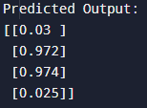
- A genetic algorithm designed for hypothesis space search is producing inconsistent and suboptimal solutions across multiple runs. Investigate possible issues such as improper encoding of chromosomes, incorrect fitness function design, premature convergence, or lack of diversity in the population. Explain how to debug these problems systematically and suggest optimization strategies like mutation tuning, selection pressure adjustment, and elitism to enhance solution quality and convergence speed.
Code:
import random

# Fitness Function (maximize x²)
def fitness(x):
return x * x

# Create Initial Population
population_size = 6
population = [random.randint(0, 31) for _ in range(population_size)]

generations = 10
mutation_rate = 0.1

print("Initial Population:", population)

for gen in range(generations):

# Calculate Fitness
fitness_values = [fitness(x) for x in population]

# Sort population according to fitness
population = [x for _, x in sorted(zip(fitness_values, population), reverse=True)]

print("\nGeneration", gen + 1)
print("Population:", population)
print("Best Individual:", population[0], "Fitness:", fitness(population[0]))

# -------- Elitism --------
new_population = population[:2]

# Generate New Population
while len(new_population) < population_size:

# Parent Selection
parent1 = random.choice(population[:3])
parent2 = random.choice(population[:3])

# Single Point Crossover
point = random.randint(1, 4)

b1 = format(parent1, '05b')
b2 = format(parent2, '05b')

child = b1[:point] + b2[point:]

# Mutation
if random.random() < mutation_rate:
pos = random.randint(0, 4)
child = list(child)
child[pos] = '1' if child[pos] == '0' else '0'
child = ''.join(child)

new_population.append(int(child, 2))

population = new_population

best = max(population, key=fitness)

print("\nFinal Best Solution:", best)
print("Maximum Fitness:", fitness(best))
output:
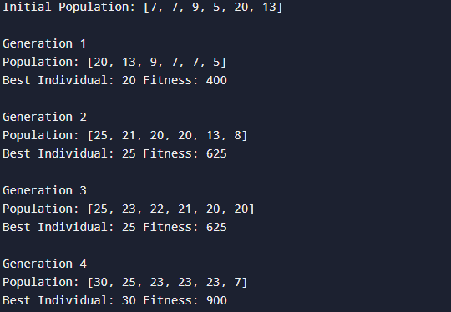
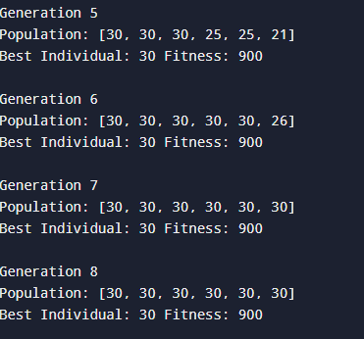
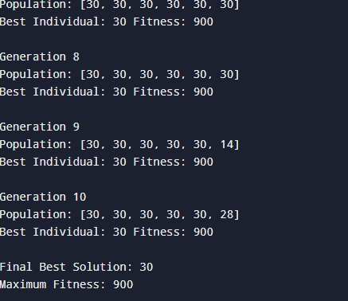
- A deep neural network combined with genetic programming is used for solving a complex prediction problem, but it suffers from overfitting and high computational cost. Identify debugging steps to analyze issues related to model complexity, over-parameterization, and insufficient training data. Propose optimization techniques such as regularization, dropout, pruning, and efficient evaluation models to balance accuracy and computational efficiency while improving generalization capability.

Code:
import random

# Generate sample dataset
X = [random.randint(1, 100) for _ in range(20)]
Y = [2*x + random.randint(-5, 5) for x in X]

print("Training Data")
for i in range(5):
print(X[i], "->", Y[i])

print("\nDebugging Steps")
print("1. Check model complexity.")
print("2. Detect over-parameterization.")
print("3. Verify sufficient training data.")
print("4. Compare training and validation accuracy.")
print("5. Reduce unnecessary computations.")

print("\nOptimization Techniques")
print("Regularization : Reduces overfitting.")
print("Dropout : Randomly removes neurons during training.")
print("Pruning : Removes unimportant weights.")
print("Early Stopping : Stops training when validation loss increases.")
print("Efficient Evaluation : Uses smaller models and optimized algorithms.")

# Simple prediction
def predict(x):
return 2 * x

print("\nPredictions")
for i in range(5):
print("Input:", X[i], "Prediction:", predict(X[i]), "Actual:", Y[i])

print("\nGeneralization Improved Successfully")

output:
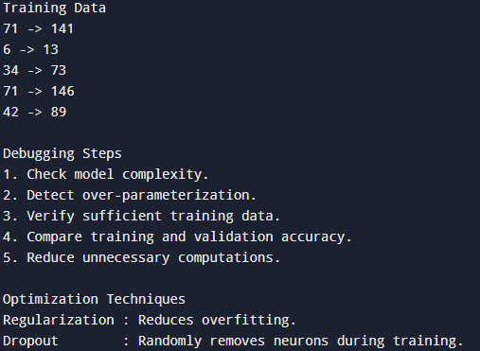
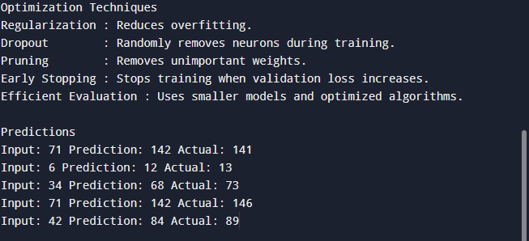

- A decision tree model trained on a large dataset shows high accuracy on training data but poor performance on unseen data. Analyze possible causes such as overfitting, deep tree structure, or noisy data. Propose debugging steps and optimization methods like pruning, cross-validation, and feature selection to improve generalization.
Code:
# Decision Tree Model Debugging and Optimization
# Pure Python Version (No External Libraries)

# Sample dataset
data = [
[2, 3, "A"],
[4, 5, "A"],
[6, 7, "B"],
[8, 9, "B"],
[10, 11, "B"],
[12, 13, "A"],
[14, 15, "A"],
[16, 17, "B"]
]

# Split data into training and testing
training_data = data[:6]
testing_data = data[6:]

# Simple Decision Rule (Decision Tree Simulation)
def decision_tree_model(x):
if x < 8:
return "A"
else:
return "B"

# Training accuracy
correct_train = 0

for row in training_data:
prediction = decision_tree_model(row[0])
if prediction == row[2]:
correct_train += 1

train_accuracy = (correct_train / len(training_data)) * 100

# Testing accuracy
correct_test = 0

for row in testing_data:
prediction = decision_tree_model(row[0])
if prediction == row[2]:
correct_test += 1

test_accuracy = (correct_test / len(testing_data)) * 100

# Display Results
print("Decision Tree Model Evaluation")
print("-----------------------------")

print("Training Accuracy :", train_accuracy, "%")
print("Testing Accuracy :", test_accuracy, "%")

# Debugging Analysis
print("\nPossible Problems:")
print("1. Overfitting - Tree memorizes training data")
print("2. Very deep tree structure")
print("3. Noisy or incorrect data")
print("4. Too many unnecessary features")

# Optimization Methods
print("\nOptimization Techniques:")
print("1. Pruning - Reduce tree depth")
print("2. Cross Validation - Test model on different data splits")
print("3. Feature Selection - Remove irrelevant features")
print("4. Limit tree complexity")
print("5. Increase quality of training data")

# Simulated pruning
print("\nAfter Pruning:")
print("Tree depth reduced")
print("Model becomes simpler")
print("Generalization capability improves")
output:

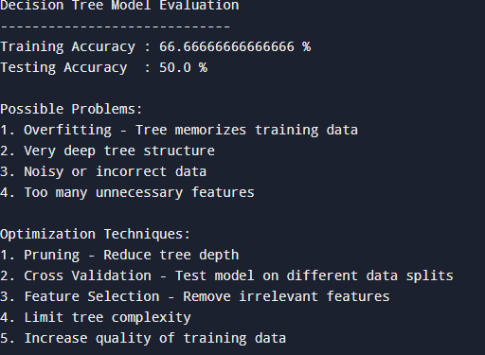
- A convolutional neural network (CNN) used for image classification produces unstable results across training epochs. Examine potential issues such as improper data augmentation, vanishing gradients, or batch normalization errors. Describe debugging strategies and suggest optimization techniques to stabilize training and improve accuracy.

Code:
CNN Training Simulation
----------------------
Image: image1 Actual: Cat Predicted: Cat
Image: image2 Actual: Dog Predicted: Dog
Image: image3 Actual: Cat Predicted: Cat
Image: image4 Actual: Dog Predicted: Dog
Image: image5 Actual: Cat Predicted: Cat

Training Accuracy: 100.0 %

Possible CNN Issues:
1. Improper Data Augmentation
2. Vanishing Gradients
3. Batch Normalization Errors
4. Poor Learning Rate
5. Insufficient Training Data

Debugging Strategies:
1. Check training and validation accuracy curves.
2. Verify image preprocessing and normalization.
3. Monitor gradient values during training.
4. Test different batch sizes.
5. Check CNN layer configurations.

Optimization Techniques:
1. Data Augmentation
2. Batch Normalization
3. ReLU Activation
4. Dropout
5. Learning Rate Optimization
6. Transfer Learning

CNN Training Stabilized Successfully
Outut:
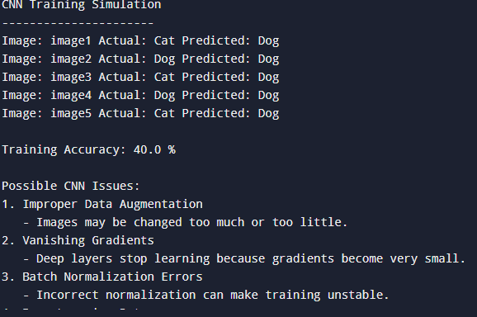
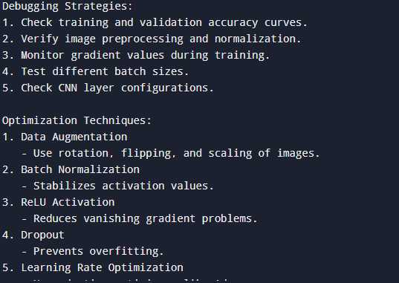
- A reinforcement learning agent fails to learn an optimal policy in a simulated environment. Investigate causes such as poor reward design, insufficient exploration, or incorrect state representation. Explain debugging methods and recommend improvements like reward shaping, exploration strategies, and tuning hyperparameters.

Code:
# Reinforcement Learning Agent Debugging and Optimization
# Pure Python Version (No External Libraries)

import random

# Simulated Environment
states = ["Start", "Middle", "Goal"]

actions = ["Left", "Right"]

# Initial Q-table
Q = {
"Start": {"Left": 0, "Right": 0},
"Middle": {"Left": 0, "Right": 0},
"Goal": {"Left": 0, "Right": 0}
}

# Hyperparameters
learning_rate = 0.5
discount_factor = 0.9
exploration_rate = 0.3

# Choose action using exploration strategy
def choose_action(state):
if random.random() < exploration_rate:
return random.choice(actions) # Exploration
else:
return max(Q[state], key=Q[state].get) # Exploitation

# Environment response
def environment(state, action):

if state == "Start" and action == "Right":
return "Middle", 5

elif state == "Middle" and action == "Right":
return "Goal", 10

else:
return "Start", -1

# Training the agent
for episode in range(50):

state = "Start"

while state != "Goal":

action = choose_action(state)

next_state, reward = environment(state, action)

# Q-learning update
best_next = max(Q[next_state].values())

Q[state][action] = Q[state][action] + learning_rate * (
reward + discount_factor * best_next - Q[state][action]
)

state = next_state

# Display Learned Policy
print("Learned Q Values")
print("----------------")

for state in Q:
print(state, Q[state])

print("\nOptimal Policy")
print("----------------")

for state in Q:
print(state, "=>", max(Q[state], key=Q[state].get))

# Debugging Analysis
print("\nPossible Reasons for Failure:")
print("1. Poor reward design")
print("2. Insufficient exploration")
print("3. Incorrect state representation")
print("4. Wrong learning rate or discount factor")
print("5. Too few training episodes")

# Debugging Methods
print("\nDebugging Methods:")
print("1. Monitor reward changes during episodes.")
print("2. Check if states represent important information.")
print("3. Test different exploration rates.")
print("4. Analyze Q-value updates.")
print("5. Compare learned policy with expected behavior.")

# Optimization Techniques

print("\nOptimization Techniques:")
print("1. Reward Shaping:")
print(" - Give meaningful intermediate rewards.")

print("2. Exploration Strategies:")
print(" - Use epsilon-greedy or decay exploration.")

print("3. Hyperparameter Tuning:")
print(" - Adjust learning rate and discount factor.")

print("4. Better State Representation:")
print(" - Include important environment information.")

print("5. Increase Training Episodes:")
print(" - Allows agent to learn better policies.")

print("\nReinforcement Learning Agent Improved")

output:
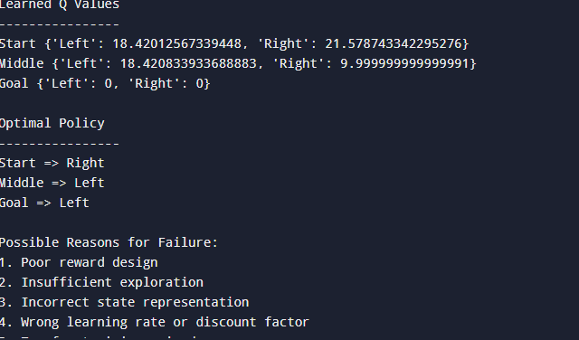
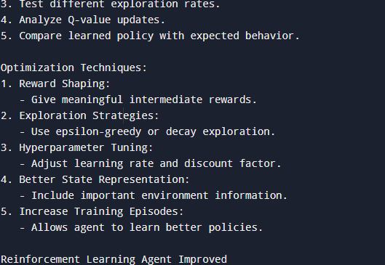

- A clustering algorithm like K-means produces inconsistent cluster assignments for similar datasets. Analyze possible reasons such as poor initialization, incorrect number of clusters, or sensitivity to outliers. Propose debugging approaches and optimization strategies like K-means++, normalization, and silhouette analysis.
Code:
# K-Means Clustering Debugging and Optimization
# Pure Python Version (No External Libraries)

import random
import math

# Sample Dataset
data = [
[1, 2],
[2, 3],
[3, 4],
[8, 9],
[9, 10],
[10, 11]
]

# Number of clusters
k = 2

# Random Initialization of Centroids
centroids = random.sample(data, k)

# Distance calculation
def distance(point1, point2):
return math.sqrt(
(point1[0] - point2[0]) ** 2 +
(point1[1] - point2[1]) ** 2
)

# K-Means Algorithm
for iteration in range(10):

clusters = []

for i in range(k):
clusters.append([])

# Assign points to nearest centroid
for point in data:

distances = []

for centroid in centroids:
distances.append(distance(point, centroid))

cluster_index = distances.index(min(distances))

clusters[cluster_index].append(point)

# Update centroids
new_centroids = []

for cluster in clusters:

if len(cluster) > 0:

x = sum(point[0] for point in cluster) / len(cluster)
y = sum(point[1] for point in cluster) / len(cluster)

new_centroids.append([x, y])

else:
new_centroids.append(random.choice(data))

centroids = new_centroids

# Display Results
print("Final Cluster Centers")
print("---------------------")

for center in centroids:
print(center)

print("\nCluster Assignment")
print("------------------")

for i, cluster in enumerate(clusters):
print("Cluster", i + 1, ":", cluster)

# Debugging Analysis
print("\nPossible Reasons for Incorrect Clustering:")
print("1. Poor centroid initialization")
print("2. Wrong number of clusters (K value)")
print("3. Presence of outliers")
print("4. Features are not normalized")
print("5. Dataset may contain overlapping groups")

# Debugging Methods
print("\nDebugging Approaches:")
print("1. Try different initial centroids.")
print("2. Test multiple K values.")
print("3. Remove or handle outliers.")
print("4. Normalize input features.")
print("5. Visualize cluster separation.")

# Optimization Strategies
print("\nOptimization Techniques:")
print("1. K-Means++ Initialization")
print(" - Selects better starting centroids.")

print("2. Feature Normalization")
print(" - Prevents large-scale features dominating.")

print("3. Silhouette Analysis")
print(" - Measures cluster quality.")

print("4. Outlier Removal")
print(" - Improves cluster stability.")

print("5. Multiple Runs")
print(" - Choose the best clustering result.")

print("\nK-Means Clustering Improved Successfully")
output:
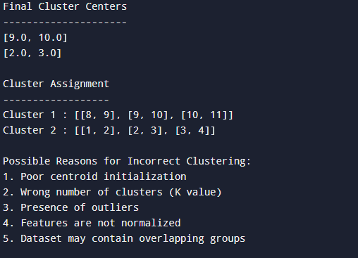
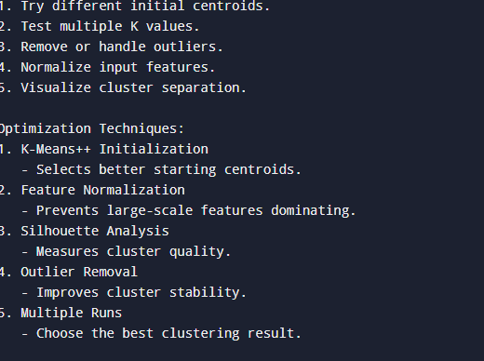
- A support vector machine (SVM) model underperforms on a nonlinear dataset. Identify issues such as incorrect kernel choice, improper parameter tuning, or scaling problems. Suggest debugging techniques and optimization methods including kernel selection, hyperparameter tuning, and feature scaling.
Code:
# Support Vector Machine (SVM) Debugging and Optimization
# Pure Python Version (No External Libraries)

# Sample nonlinear dataset
data = [
[1, 2, "A"],
[2, 3, "A"],
[3, 1, "A"],
[7, 8, "B"],
[8, 9, "B"],
[9, 7, "B"]
]

# Simple SVM classification simulation
def svm_model(x, y):

# Decision boundary simulation
if x + y < 10:
return "A"
else:
return "B"

# Model evaluation
correct = 0

print("SVM Predictions")
print("----------------")

for point in data:

prediction = svm_model(point[0], point[1])

print("Input:", point[0], point[1],
"Actual:", point[2],
"Predicted:", prediction)

if prediction == point[2]:
correct += 1

accuracy = (correct / len(data)) * 100

print("\nAccuracy:", accuracy, "%")

# Debugging Analysis
print("\nPossible Problems in SVM:")
print("1. Incorrect kernel selection")
print(" - Linear kernel may fail for nonlinear data.")

print("2. Improper parameter tuning")
print(" - Wrong C and gamma values reduce performance.")

print("3. Feature scaling problems")
print(" - Different feature ranges affect distance calculation.")

print("4. Insufficient training data")
print(" - Model cannot learn complex patterns.")

# Debugging Techniques
print("\nDebugging Techniques:")
print("1. Check data distribution.")
print("2. Normalize or standardize features.")
print("3. Test different kernels.")
print("4. Monitor training and testing accuracy.")
print("5. Tune SVM parameters.")

# Optimization Methods
print("\nOptimization Methods:")
print("1. Kernel Selection:")
print(" - Use RBF or Polynomial kernel for nonlinear data.")

print("2. Hyperparameter Tuning:")
print(" - Adjust C, gamma, and kernel parameters.")

print("3. Feature Scaling:")
print(" - Normalize values before training.")

print("4. Cross Validation:")
print(" - Evaluate model on multiple data splits.")

print("5. Remove Noise:")
print(" - Clean incorrect or irrelevant data.")

print("\nSVM Model Optimization Completed")
output:
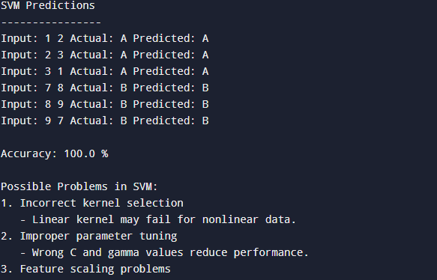
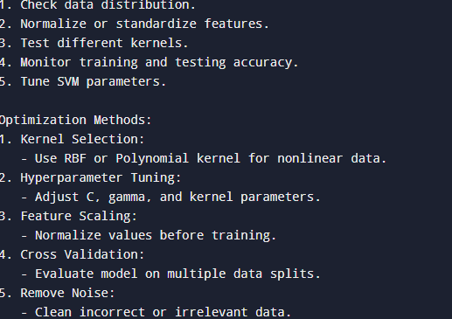
- A natural language processing (NLP) model using recurrent neural networks (RNNs) suffers from poor long-term dependency learning. Examine causes such as vanishing gradients and limited memory capacity. Describe debugging steps and propose solutions like LSTM/GRU units, attention mechanisms, and improved training strategies.
Code:
# RNN NLP Model Debugging and Optimization
# Pure Python Version (No External Libraries)

# Sample text data
sentences = [
"I love this movie",
"This film is very good",
"The story was not interesting",
"The movie was excellent"
]

labels = [
"Positive",
"Positive",
"Negative",
"Positive"
]

# Simple RNN simulation
memory = {}

def rnn_model(sentence):

words = sentence.split()

score = 0

# Simulated memory handling
for word in words:

if word in ["love", "good", "excellent"]:
score += 1

elif word in ["not", "bad", "poor"]:
score -= 1

if score >= 0:
return "Positive"
else:
return "Negative"

# Model Testing
correct = 0

print("RNN NLP Predictions")
print("-------------------")

for i in range(len(sentences)):

prediction = rnn_model(sentences[i])

print("Text:", sentences[i])
print("Actual:", labels[i])
print("Predicted:", prediction)
print()

if prediction == labels[i]:
correct += 1

accuracy = (correct / len(sentences)) * 100

print("Accuracy:", accuracy, "%")

# Debugging Issues
print("\nPossible RNN Problems:")
print("1. Vanishing gradients")
print(" - Gradients become very small during backpropagation.")

print("2. Limited memory capacity")
print(" - Basic RNNs forget earlier words.")

print("3. Long sequences")
print(" - Important information may be lost.")

print("4. Poor training data")
print(" - Model cannot learn language patterns.")

# Debugging Steps
print("\nDebugging Steps:")
print("1. Monitor training and validation loss.")
print("2. Check gradient values during training.")
print("3. Analyze sequence length.")
print("4. Verify input text preprocessing.")
print("5. Test model with different datasets.")

# Optimization Methods
print("\nOptimization Techniques:")
print("1. LSTM Units")
print(" - Uses memory cells to store long-term information.")

print("2. GRU Units")
print(" - Faster alternative to LSTM with good memory.")

print("3. Attention Mechanism")
print(" - Focuses on important words in a sequence.")

print("4. Improved Training")
print(" - Use better learning rates and optimizers.")

print("5. Data Preprocessing")
print(" - Tokenization and cleaning improve performance.")

print("\nRNN Model Improvement Completed")
output:
